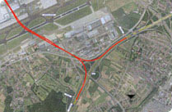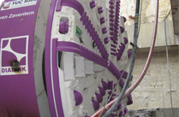Diabolo Tunnel

an existing motorway bridge and addition of a new bridge

|  |  |
| --- | --- |
| General Data: | |
| **Project:** | Diablo railway tunnel |
| **Client:** | Ways & Freytag Ingenieurbau AG in joint venture with Vinci Construction Grand Projects |
| **Delivery period:** | 2008 - 2009 |
| **Scope of work:** | Conversion of the dead-end station at Zaventem Airport, Brussels, into a through station; connection of the station to the new high-speed railway line from Brussels to Antwerp   * 2 TBM-driven tunnels, length: 1,07 km each, external diameter 8,00 m, 1428 rings of 7+1 segments |
| Sealing method: | Maximum hydraulic pressure 2,3 bars,  Test pressure 4,6 bars at worst combination of 5 mm gap and 20 mm offset  SANY0024Tunnel Flex 33 Plus, Rubber gaskets with 90° Soft corners |
|  | TS 33x11 (8) PLUS E 106.wmf |
| **Additional information:** | ES Rubber Ltd. | Kibbutz Ein Shemer | M.P. Hefer 38816, Israel | +972.4.637.1037 | [export@esrubber.com](mailto:export@esrubber.com) | www.esrubber.com  Dr. Werner Grabe mobile +49 174 6884223 |